Head lamp

 | Picture & description | price
 | 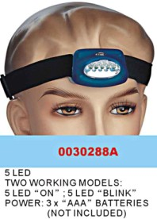 | usd1.40/pc, blister card pack.
 | 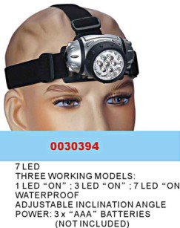 | usd2.15/pc, blister card pack.
 | 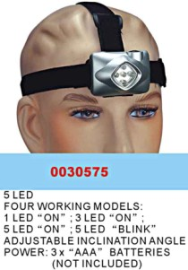 | usd2.00/pc, blister card pack.
 | 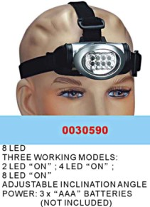 | usd2.35/pc, blister card pack
 | 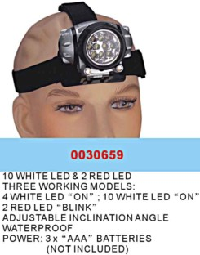 | usd2.70/pc, blister card pack
 | 0030709  12LED  Four working models :  4 LED “ON” ; 8LED “ON”; 12LED “ON”; 12 LED “BLINK”  Waterproof  Adjustable inclination angle  Power: 3* “AAA” batteries (Not included) | usd2.55/pc, blister card pack

